26.13.16 Editors - Properties Editor - Object Data Properties Tab - Point Cloud Object
Point Cloud 1
Attributes panel 1
List View 1
Position Attribute 1
Search Field 2
Add Attribute menu 2
Radius 2
Color 2
Particle ID 2
Velocity 2
Custom 2
Name 2
Data Type 2
Float 2
Integer 2
Vector 2
Float Color 2
Byte Color 3
String 3
Domain 3
Remove Geometry Attribute 3
Custom Properties Panel 3
Add 3
Edit 3
Remove 3

Point Cloud

Point clouds can represent 3D scans. It is also planned to represent particles in the future. Each point can store data in a set of Attributes. These attributes can be managed here.

Attributes panel

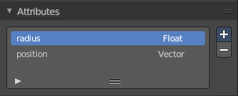
The Attributes panel contains different point cloud characteristics such as the position and size of points. This data can then for example be used in the shader editor or in the compositor editor.

List View
A list of the attributes.

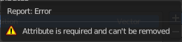
Position Attribute
The position of the point in 3D space. Type Vector. Not in the menu. This attribute exists from the beginning. And can't be added or removed.

Search Field

You can expand a search field at the bottom of the list. Type in your term and hit enter to filter for your term.

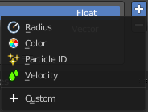
Add Attribute menu

Radius
The radius of each point. Type Float.

Color
The color of each point. Type Float Color.

Particle ID
A unique identifier given to each particle. Type Integer.

Velocity
The speed and direction that the particle is traveling. Type Vector.

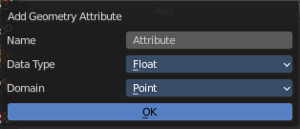
Custom
Custom attribute can be given to particles to hold a custom characteristic. Clicking this menu item will open a popup where you can adjust the custom properties.

Name
The name of the attribute.

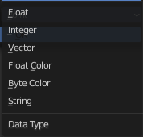
Data Type
The type of data to store in the attribute.

Float
Floating point value.

Integer
32-bit integer.

Vector
3D vector with floating point values.

Float Color
RGBA color with floating point precision.

Byte Color
RGBA color with 8-bit precision.

String
Text string.

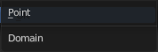
Domain
The type of element the attribute is stored in. Currently, attributes can only be stored per Point.

Remove Geometry Attribute
Remove the attribute from the list.

Custom Properties Panel


Here you can define custom properties that can be used for scripting.

Here you might also find custom properties from addons or scripts.

Add
Adds a new property.


Edit
Opens a panel where you can adjust the settings for the custom property.

Remove
Removes the property.

